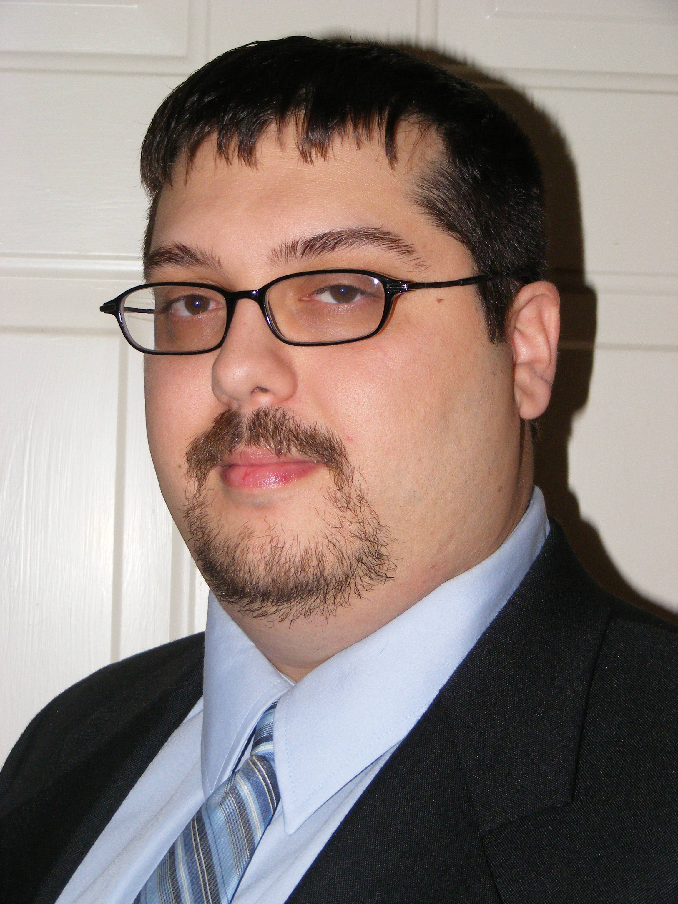

Messod Bendayan
messody14@gmail.com
386-225-6870
www.MessodBendayan.com
___________________________________________________________________________________________________

Recent Work Experience

News Anchor/Reporter Cox Media Group - Jacksonville
- Main reporter for Jacksonville’s Morning News on News 104.5 WOKV
- Provide social media content and articles for WOKV
- Cover breaking news and anchor shifts on-air as needed

Sports Talk Show Producer SiriusXM College Sports Nation
- Main producer for College Sports Coast To Coast
- Responsible for bookings, production, show format & social media
- Filled in as a producer/board op for other programs as assigned

Additional Broadcast/Other Related Experience

• General Manager/News & Sports Director WRGP
• News Host/Reporter/Anchor/Producer WNDB, WSJS, Metro, WFTL
• Sports Host/Reporter/Anchor/Producer IMG, CP, Metro, WFLL
• Traffic Reporter/Anchor/Producer WNDB, WQAM, Metro
• Gameday/Show Producer & Board Op IMG, CP, WSJS, WQAM
• Play-By-Play Announcer Stetson, WRGP
• Public Address/Stadium Announcer Stetson, FIU Athletics
• Newspaper Copy Editor/Writer/Columnist The Beacon

Related Skills

• Bi-lingual (English, Spanish)
• Website management (Medley, Wordpress, Joomla, Zeeblio, Trellix)
• Social media management (Facebook, Twitter, Instagram)
• Audio editing software (NewsBoss, Scott Studios, Adobe Audition
Sound Forge, Dalet, Goldwave, Audacity
ACID/Vegas, Audio Vault)
• News wire software (NewsBoss, RCS, Metro Source, Associated Press)
• Microsoft Office (Word, Excel, Outlook, PowerPoint, Paint, Access)

Education

B.S. Communications (Business Minor)
Florida International University

References

• Rich Jones News Director/Show Host, CMG (Jacksonville)
904-718-7503; rich.jones@coxinc.com
• Leslie Taylor Former News Director, Southern Stone (Daytona)
804-301-3769
• TJ Cutini Former Director, SiriusXM College Sports Nation
336-970-3805; tcutini@gmail.com
Where I’ve Worked

Cox Media Group (WOKV)
Jacksonville, FL
2016 – 2017

Stetson University
DeLand, FL
2014 – 2016

Southern Stone (WNDB)
Daytona Beach, FL
2012 – 2016

SiriusXM
Washington, DC
2012

Carolina Panthers
Charlotte, NC
2010 – 2012

IMG College
Winston-Salem, NC
2009 – 2012

Curtis Media (WSJS)
Winston-Salem, NC
2007 – 2009

FIU Athletics
Miami, FL
2006 – 2007

Metro Networks
Miami, FL
2006 – 2007

Beasley Broadcast (WQAM)
Miami, FL
2006 – 2007

James Crystal (WFTL/WFLL)
Ft. Lauderdale, FL
2005 – 2006

Beacon/WRGP (FIU)
Miami, FL
2000 – 2005

